First Author Name¹, Second Author Name², Third Author Name³, Fourth Author Name⁴
¹Affiliation, Department, Institution, City, Country
²Affiliation, Department, Institution, City, Country
Email ID of Corresponding Author: xxxxx@domain.com

Abstract.
Here write the abstract - 150 – 200 words in English! (TIMES NEW ROMAN (TNR) 12 pt., spacing 1.5). The abstract should clearly present the objective, methodology, key results, and significance of the research. It should be concise and self-contained, avoiding citations, equations, and abbreviations where possible. The abstract must reflect the novelty and contribution of the work and highlight its relevance to the conference theme Innovation, Visionary Engineering, and Next-generation Technology.
Keywords: key word, key word, key word (max 5 key words in English)

Introduction (TNR 12pt., bold)
The main text, (TIMES NEW ROMAN 12 pt., spacing 1.5) text, text, text, text, text, text, text, text, text, text, text, text, text, text, text, text, text, text, text, text, text, text, text, text, text, text, text, text, text, text, text, text, text, text, text, text, text, text, text, text, text, text, text, text, text, text, text, text, text, text, text, text, text.

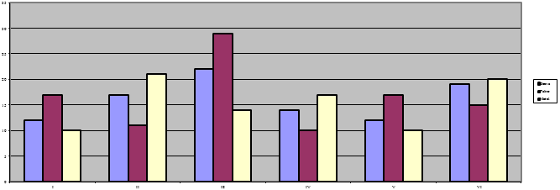
Figure 1: Figure description (TNR 10pt., centered, italics)
Text, text, text, text, text, text, text, text, text, text, text, text, text, text, text, text, text, text, text, text, text, text, text, text, text, text, text, text.

1.1 Title of the 2nd level (TNR 12pt., bold)
Text, text, text, text, text, text, text, text, text, text, text, text, text, text, text, text, text, text, text, text, text, text, text, text, text, text, text, text, text, text, text, text, text, text, text, text, text, text, text, text, text, text, text, text, text, text, text, text, text, text.

Title of the 3rd level (TNR 12pt., bold)
Text, text, text, text, text, text, text, text, text, text, text, text, text, text, text, text, text, text, text, text, text, text, text, text, text, text, text, text, text, text, text, text, text, text, text, text, text, text.
Tables and figures should be numbered and references to them must be in the text. Acceptable labeling for a table is Tab.1 and Fig. 1 for a figure.
Table 1: Table description (TNR 10pt., italics)
Times New Roman 10pt | Times New Roman 10pt | Times New Roman 10pt
Times New Roman 10pt | Times New Roman 10pt | Times New Roman 10pt
Times New Roman 10pt | Times New Roman 10pt | Times New Roman 10pt
Times New Roman 10pt | Times New Roman 10pt | Times New Roman 10pt
Equations
Equations (refer with: Eq. 1, Eq. 2,...) should be placed in the middle, denoted by numbers in round parentheses and transformed by equation conversion manager, do not use Print Screen or jpg format. For example:
(1)

Body of paper (TNR 12pt., bold)
The article must be divided into chapters. Introduction and conclusion are obligatory. It is recommended to adjust body of the paper to the common organization structure of scientific papers – (Introduction, Methods, Results and Discussion).

Conclusion (TNR 12pt., bold)
References (TNR 12pt. bold)
References in text should have this form (surname, year), for example:

- Lulu Wen, Kaile Zhou, Shanlin Yang and Lanlan Lia (2018) “Compression of smart meter big data: A survey”, Renewable and Sustainable Energy Reviews, vol.91, pp.59-69.

